Instruction of Abstracts Submission to the Conference
The title of your abstract should be typed without hyphenation and a dot at the end, font size 12, semi-bold type
Name, Patronymic and Last Names ¹⁾, N.P.L.N ²⁾, N.P.L.N ¹⁾
¹ A.F. Ioffe Physico-Technical Institute, Saint-Petersburg
194021, 26 Polytechnicheskaya str.
² SPSU, Saint-Petersburg, 195251, 29 Polytechnicheskaya str.
phone:+7 (812) 247-2245, fax: +7 (812) 247-1017 , e-mail: user@mail.ru

The present Instruction is typed in the Word textual editor to be used when preparing your abstracts for submission. The template contains the following styles: Heading1, Heading2, Authors, Affiliations, Connections, BodyText, NumList. The styles should not be modified by an author and they should be used according to their names.

Abstract design
- Abstracts are to be designed in the Word (2000-2003-2007) format based on the template used in the present instruction: Times New Roman, single spacing, font size 11, semi-bold type. The text should be levelled in width with no hyphenation. Margins: upper, lower – 25 mm; left, right – 30 mm.
- An author’s first, patronymic and last names should be set to the semi-bold type. Figures should be built in the text. Besides, it is necessary to send their original files on the electronic address of the Organizing Committee. Figure captions should be typed at a font size not smaller than 9.

- 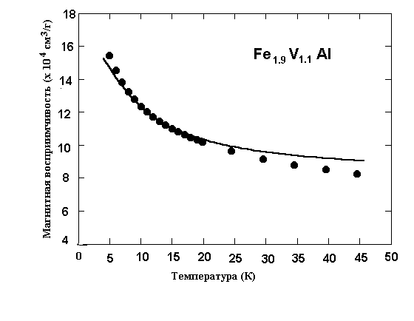The abstracts volume, including tables and in-built figures, should not exceed 1 page of format A4.
- Formulas and mathematical indications should be typed assisted with a formula editor.
- The cited references are given as a general list following the text. The list is numbered in figures in square brackets [1]. In case there are more than 3 authors of a cited contribution, it is sufficient to indicate first, patronymic and last names of the first co-author [2].
- The number of the chapter which, in an author’s opinion, the presented report refers to, should be typed in the right corner of the upper running title and include it in the Subject line of an electronic letter.

References
1. V.Y. Demikhovsky, G.A. Vugalter, Physics of quantum low-dimensional structures. M.: Logos publ., 2000. 247 p. (in Russian).
2. G.A. Kachurin et al. // SPT. 2001. V. 35, i. 10. P. 1235-1239 (in Russian).

