Ge/Si quantum dot nanostructures grown with low energy ion-beam assisted epitaxy.

A. V. Dvurechenskii, J.V. Smagina, R.Groetzschel*, V.A. Zinovyev, V.A. Armbrister,
P.L. Novikov, S.A. Teys, A.K.Gutakovskii
Institute of Semiconductor Physics, 630090, Novosibirsk, Russia
*Research Center Rossendorf, D-01314, Dresden, Germany

Scanning tunneling microscopy (STM) and reflection high-energy electron diffraction (RHEED) experiments were performed to study growth modes induced by hyperthermal Ge⁺ ion action during molecular beam epitaxy (MBE) of Ge on Si(100). The continuous and pulsed ion beams were used. These studies have shown that ion-beam bombardment during heteroepitaxy leads to decrease in critical film thickness for transition from two-dimensional (2D) to tree-dimensional (3D) growth modes, enhancement of 3D island density and narrowing of island size distribution, as compared with conventional MBE experiments. Moreover, it was found that ion beam assists the transition from hut to dome shaped Ge islands on Si(100). The crystal perfection of Ge/Si structures with Ge islands embedded in Si was analyzed by Rutherford backscattering/channeling technique (RBS) and transmission electron microscopy (TEM). The studies of Si/Ge/Si(100) structures indicated defect-free Ge nanopaticles and Si layers for the initial stage of heteroepitaxy (5 monolayers of Ge) in pulsed ion beam action growth mode at 350⁰C. Continuous ion beam irradiation was found to induce dislocations around Ge clusters. The results of kinetic Monte-Carlo (KMC) simulation have shown that two mechanisms of ion beam action can be responsible for stimulation of 2D - 3D transition. They are: 1) surface defect generation by ion impacts and 2) enhancement of surface diffusion.

1. Introduction
Self-assembled Ge islands on Si(100) have been intensively investigated as the basis of future electronic and optical devices [1,2]. The self-assembled (ordering) effects imply the appearance of islands with preferred characteristics: sizes, shapes, spacing between nanoclusters, and their mutual arrangement. The ordering processes are accompanied by the minimization of free energy of the system. At present, particular attention is being given to the size distribution of islands, because this parameter of a system of quantum dots is of crucial importance in practical applications. At present, it is commonly accepted that the energy gain caused by the strain relaxation in island apexes is the key factor in the transition from a two-dimensional to three-dimensional island growth. The 3D islands are formed due to the morphological instability of strained films in systems with a large (more than 2 %) lattice mismatch between a film and substrate, among which Ge/Si (4%) and InAs/GaAs (7%) are most familiar.
The conventional way to control island formation (size, shape and density) is variation of growth conditions by the alteration of substrate temperature and molecular flux. However, to establish a method to achieve sufficiently uniform island sizes with regular spatial distribution still remains a critical issue. This should be solved since a well defined sizes with little dispersion are generally required for any practical applications. The new facility to tune island dimensions and their surface densities is expected to be the use of ion beam with energy exceeding the energy in the molecular beam, but less than the energy of defects generation in the bulk of growing layer (and substrate). The results of our recent study indicate that irradiation with low-energy Ge⁺ ions during Ge/Si(111) heteroepitaxy stimulates the nucleation of 3D Ge islands and reduces the critical thickness at which the 2D - 3D transition occurs [3,4].
In this work we present the results of investigation of size ordering and shape transition in an ensemble of Ge nano-islands formed by Ge/Si(100) heteroepitaxy under low energy ion-beam irradiation and crystal perfection of Ge/Si structures with quantum dots embedded in Si. In order to clarify the effect of the ion irradiation on 3D island nucleation we have carried out the simulation of ion assisted growth of Ge films on Si by Kinetic Monte Carlo (KMC) method.

2. Experimental
The experiments were carried out in an ultrahigh-vacuum chamber of molecular beam epitaxy setup equipped with electron-beam evaporator for Si and effusion cell (boron nitride crucible) for Ge. A system of ionization and acceleration of Ge⁺ ions provided the degree of ionization of Ge molecular beam from 0.1 to 0.5 %. A pulsed accelerating voltage supply unit generated ion-current pulses with duration of 0.5-1 s and ion energy of 50-200 eV. The angle of incidence of the molecular and ion beams on the substrate was 54⁰ to surface normal. The analytical section of the chamber included a reflection high-energy (20 keV) electron diffraction unit.
Heteroepitaxy was carried out at substrate temperature varied in the range of 300-500⁰C. The rate of Ge deposition varied from 0.05 to 0.1 monolayer (ML) per second. We investigated three types of Ge/Si(100) heterostructures grown by 1) conventional MBE of Ge on Si; 2) MBE with single pulsed Ge⁺ ion beam action for each Ge monolayer completed at layer-by-layer growth mode; 3) MBE under continuous irradiation by Ge⁺ ion beam. Evоlution of surface morphology was studied in situ by RHEED and ex situ by STM. Crystal perfection of Ge/Si structures were analyzed by RBS and TEM. For that a 150 nm thick cap layer of Si was grown at 500⁰C by the conventional MBE (with no irradiation) over Ge layer.
3. Results and Discussion
Examples of STM patterns observed for structures with 5 monolayers of Ge grown on Si(100) at 350⁰C are shown in figure 1. An average size of islands obtained by conventional MBE was 22±3.5 nm and their dispersion (size inhomogeneity) was 16%. In experiments with pulsed irradiation of Ge⁺ ion beam, the average island size was 6.5±0.7 nm and dispersion was 10%. In the case of continuous irradiation with Ge⁺ ion beam the size of islands diminished (18±5.4 nm) too, but their dispersion increased (30%) in comparison with those at conventional MBE. The surface density of Ge nano-islands for the structures of second type was 6.8 10¹¹ cm⁻² which is approximately seven times higher than that for the structures of first type (~10¹¹ cm⁻²). The density of Ge nano-islands in experiments under continuous ion irradiation with Ge⁺ was 2 10¹¹ cm⁻². A decrease in the full width at half maximum of the size distribution function is evidence for the size ordering in an ensemble of Ge nanoclusters.
We found that this ordering process is caused by pulsed ion-beam actions at each Ge monolayer completed in layer-by-layer growth mode. RHEED was used for in situ control of morphology and stressed state of Ge/Si(100) surface. In addition, the starting point of hut and dome clusters formation was observed due to specific reflexes produced in RHEED images by {105} and {113} facets [2,5].
Figure 2 shows the evolution of Ge lattice constant during the conventional MBE and MBE with pulsed Ge⁺ ion beam actions. The arrows in this figure separate the stages of 2D growth, the growth of hut and dome shaped islands, respectively. One can see that the ion beam action results in the earlier 2D - 3D transition as well as the formation of dome clusters. The effect was found to be dependent on the energy of ions. Under irradiation by 200 eV ions the hut clusters are formed 1 ML earlier as compared to case of 100 eV, while dome clusters are created 2 ML earlier.
It is generally believed that the nucleation of 3D islands occurs at the imperfections of 2D layer (heterogeneous nucleation mechanism). Hence, preliminary creation of nucleation sites such as vacancy depressions by ion impacts is an efficient way to control island density [6]. Indeed, our STM results demonstrate that ion bombardment stimulates nucleation of 3D islands. However the narrowing in island size distribution is observed only in pulsed ion beam action growth mode (Fig. 1b). The continuos ion irradiation leads to reversed effect (Fig. 1c). The size ordering of the Ge islands during heteroepitaxy with pulsed Ge⁺ ion beam irradiation is, most likely, caused by the following factors: 1) a synchronization of island nucleation by pulsed ion-beam actions and 2) ion-induced enhancement of surface diffusion. The latter facilitates adatom exchange between islands.
RHEED measurements of lattice constant during Ge/Si(100) heteroepitaxy with 200eV pulsed ion beam actions showed that Ge films after formation of dome-clusters were more strained (~2%) than those in case of conventional heteroepitaxy. This means that shape transition from hut to dome clusters is driven by stress production induced by ion beam bombardment. These additional stress can be attributed to interstitial complex generated near surface by energetic particles (so-called ion-peening effect [7]).
The treatment of RBS spectrums permitted to calculate the backscattering yield for self-ordering Ge islands embedded in Si and for Si layers. The backscattering yield for perfect crystal of Si(100) is about 3%. The backscattering yield from Ge layers turns out to be sensitive to the growth conditions (Fig. 3). The perfect structure of 2.5% backscattering yield was found in a mode of a pulsed irradiation for range from 1 to 5 Ge ML deposited at temperature 350⁰C. For lower temperature 300⁰C the yield exceeded 5% in similar structures. This increase in backscattering has been observed also for even more thick Ge layers at higher temperatures of growth (400-500⁰C). The enlarged yield was found also in the structures formed with continuous beam irradiation at 300-350⁰C temperatures. The increase in backscattering yield can be attributed to altering of elastic deformation inside the Ge islands due to ion-assisted change of their size, shape and density and/or to generation and accumulation of point defects in bulk region of Ge. The yield from Si matrix slightly depends on the growth conditions and corresponds to perfect Si structure.
Transmission electron microscopy studies indicated defect-free Ge dots and Si layers for the initial stage of heteroepitaxy (5 Ge ML) in pulsed action growth mode at 350⁰C. Continuous beam irradiation was found to induce dislocations around Ge dots.

4. Modeling
The process of 2D - 3D transition under ion irradiation was simulated by Monte-Carlo method. The main elementary processes included in the model were atom deposition, diffusion and ion impacts. At the first step we have simulated the pure Ge/Si heteroepitaxy without ion irradiation. The diffusion activation energy was assumed to depend on the bonding environment and elastic energy associated with strain, E=E_{bond} − E_{strain}, where E_{bond}=n₁ E₁ + n₂ E₂, (E₁ is the nearest-neighbour binding energy, E₂ is the next nearest-neighbour binding energy, n₁ is the number of the nearest neighbours, n₂ is the number of the next nearest neighbours); E_{strain} is the strain energy per atom, calculated using Keating potential [8]. It follows from those calculations that the strain energy is maximal near the island edge and depends on the island size [9]. We took E_{strain} into account only for atoms on the island edge. The simulation of growth within above assumptions results in the 2D - 3D transition as soon as the critical thickness of Ge layer is achieved. The main features of the simulation model are presented in detail elsewhere [9,10].
At the second step we included the low energy ion beam irradiation in the model. The ion beam was assumed to be responsible for the following processes: a) sputtering of the material; b) generation of additional adatoms and surface vacancy clusters; c) ion-assisted enhancement of surface diffusion.
According to molecular dynamics simulation of low-energy interaction with Si surface [11,12], qualitatively true for Ge, an ion impact in conditions, similar to those in our experiment, produces a cluster of 10 vacancies, 9 excited adatoms and one atom sputtered.
In our simulations we used the magnitude of surface diffusion coefficient 10 times higher than that for case without ion-irradiation, which agrees with the recent experimental measurements [13,14]. The simulation has shown that the growth can occur in two regimes: 2D layer-by-layer growth, when the oscillations of surface roughness is observed, and 3D growth, when oscillations disappear (Fig. 4). The 2D-3D transition is confirmed also by images of the simulated surface. For the case when the main ion-assisted process is generation of additional adatoms and surface vacancy clusters, the 2D-3D transition occurs earlier (Fig. 4b), than in the case of the usual heteroepitaxy (Fig. 4a). The number of oscillations is reduced to 2. The density of 3D islands is higher, than that in the case of usual epitaxy taken at same amount of Ge deposited (3.4 ML, corresponding to the onset of 2D - 3D transition).
For the case when the main ion-assisted process is the enhancement of surface diffusion, we obtained, that the transition occurred at the same critical thickness as in the first case (Fig. 4c). But the size and density of islands are different. The islands become larger and higher, and density decreases. Also the surface roughness is lower in comparison with the case, when only the surface defect generation by ion beam was taken into account. The ion-assisted enhancement of surface diffusion leads to increase in average size of 2D island. As a consequence, the strain energy becomes higher, which promotes the hops atoms of from an edge to the upper layer. This leads to nucleation of 3D islands at the earlier stage of growth. The facilitation of 2D-3D transition by defect generation mechanism is interpreted as the result of ion impact producing excited adatoms, which can pile up on the top of existing 2D islands and nucleate 3D islands [15]. So, both mechanisms promote transition to 3D growth. And the simulations including both mechanisms simultaneously have shown stronger effect on 2D-3D transition (Fig. 4d). In this case the critical thickness is decreased up to 1 ML.

5. Summary
Our experimental results demonstrated that Ge/Si(100) heteroepitaxy with pulsed low-energy ion beam action enables to create defect-free three-dimensional Ge islands with small sizes and high density. Moreover, it provides the narrower size distribution of islands in comparison with conventional molecular beam epitaxy. This is promising for potential applications in technology of nanostructures. The results of kinetic Monte Carlo modeling have shown that both generation of adatoms by ion beam and enhancement of surface diffusion promote transition from two-dimensional to three-dimensional growth mode.

Acknowledgments
This work has been supported by Russian Foundation of Basic Research (Grants 02-02-16020), the Intercollegiate Scientific program "Universities of Russia-Basic Research" (Grant No. UR.01.01.019), INTAS-2001-0615.
List of references
1. K. Brunner, Rep. Prog. Phys. 65, (2002) 27
2. O.P. Pchelyakov, Yu.B. Bolkhovityanov, A.V. Dvurechenskii, A.I. Nikiforov, A.I. Yakimov, B. Voigtländer, Thin Solid Films 367, (2000) 75
3. A.V. Dvurechenskii, V.A. Zinovyev, V.A. Kudryavtsev, Zh. V. Smagina, JETP Letter 72, (2000) 190
4. A.V. Dvurechenskii, V.A. Zinovyev, Zh. V. Smagina, JETP Letter, 74, (2001) 296
5. I. Goldfarb, G.A.D. Briggs, Surf. Sci. 433–435, (1999) 449
6. G.H.Takaoka, T.Seki, K.Tsumura, J.Matsuo, Thin Solid Films 405, (2002 ) 141
7. M. Koster, H.M. Urbassek, Phys. Rev. B 64, (2001) 224111
8. P.N. Keating, Phys. Rev. 145, (1966) 637
9. A.V. Dvurechenskii, V.A. Zinovyev, V.A Kudryavtsev, J.V. Smagina, P.L. Novikov, S.A. Teys, Phys. Low-Dim. Struct. 1/2, (2002) 303
10. K.E. Khor and S. Das Sarma, Phys. Rev. B 62, (2000) 16657
11. V.A. Zinovyev, L.N. Aleksandrov, V.A. Dvurechenskii, K.-H. Heinig, D. Stock, Thin Solid Films 241, (1994) 167
12. K.-H. Heining, D. Stock, H. Boettger, V.A. Zinovyev, A.V. Dvurechenskii, L.N. Aleksandrov, MRS Proceedings 316, (1994) 1035
13. R. Ditchfield and E.G. Seebauer, Phys. Rev. B 63, (2001) 125317
14. A.V. Dvurechenskii, V.A. Zinovyev, V.A. Markov, V.A. Kudryavtsev, Surf. Sci. 425, (1999), 185
15. J. Jacobsen, B. H. Cooper, and J. P. Sethna. Phys. Rev. B 58, (1998) 15847

List of figure captions

Figure 1. STM images of 100nm x 100nm surface area and size distribution of 3D islands for three types of Ge/Si(100) heterostructures after Ge deposition of 5 ML: a) conventional MBE; b) MBE with pulsed irradiation of 100 eV Ge⁺ ions; c) MBE with continuous ion irradiation. The rate of Ge deposition is 0.1 ML/s. Substrate temperature 350⁰C.

Figure 2. Variation of Ge lattice constant during conventional MBE of Ge on Si(100) and MBE with 100 eV Ge⁺ pulsed ion beam actions. The arrows indicate the appearance of hut and dome clusters registrated by RHEED.

Figure 3. Backscattering yield from Ge embedded into Si layers as dependent on Ge layer thickness. Conventional MBE: ( ) 300⁰C, (◊) 400⁰C, (○) 500⁰C; MBE with continuous ion beam: (■)300⁰C, (●)350⁰C; MBE with pulsed ion beam: (▲) 300⁰C, (*) 350⁰C.

Figure 4. The calculated surface roughness of Ge/Si structures obtained by KMC simulation as dependent on the amount of Ge deposited. The model included: (a) no ion beam effect, (b) generation of adatoms by ion beam, (c) enhancement of surface diffusion, (d): both (b) and (c).
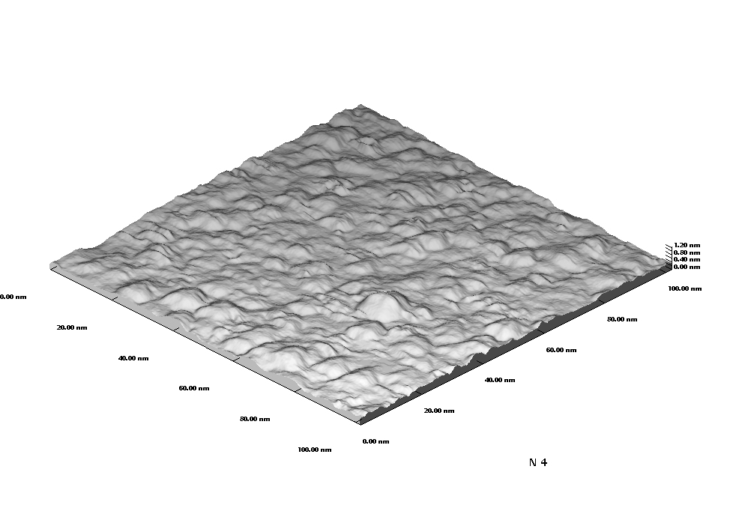
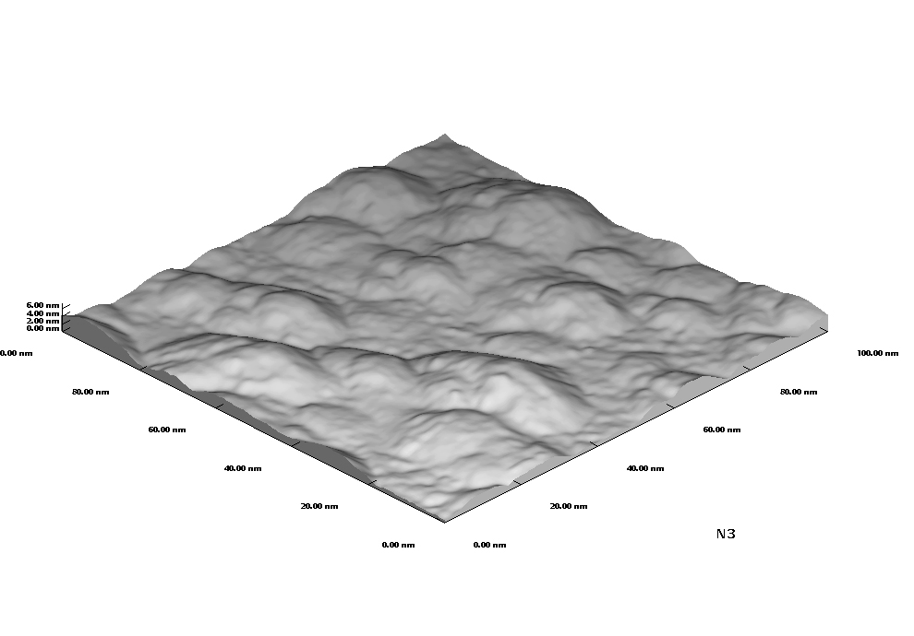
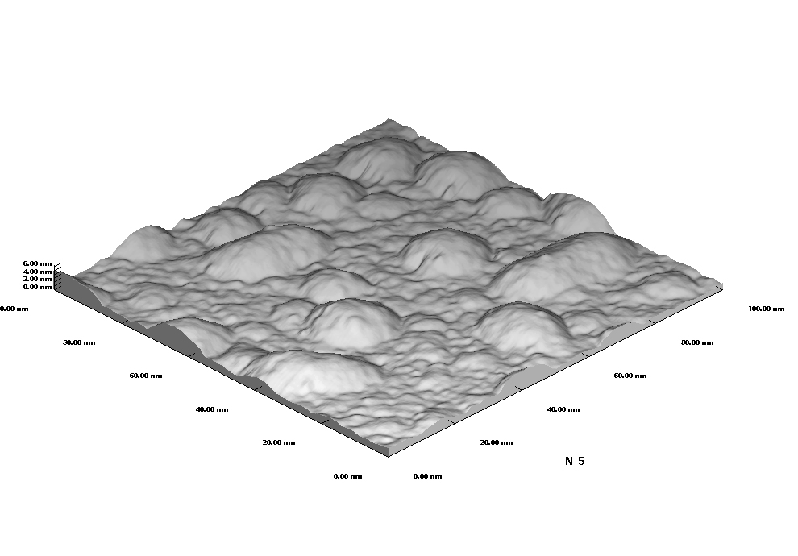
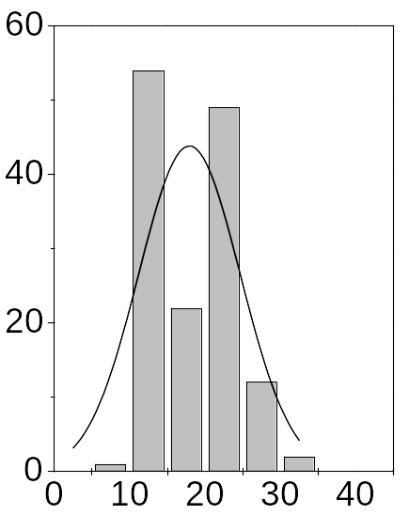
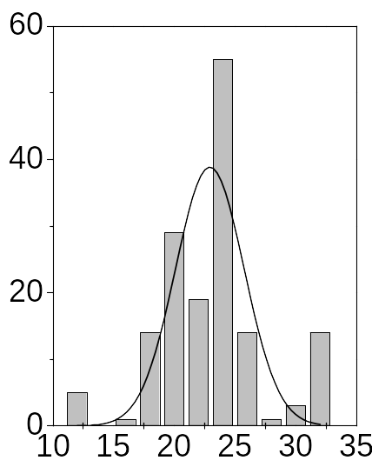
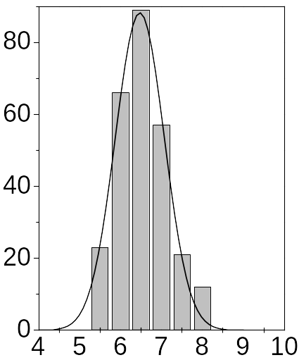
(a)
(b)
(с)
L = 22±3.5 nm
L = 6.5±0.7 nm
L =18±5.4 nm
Island base size, L (nm)
Number of islands
(b)
(d)
Figure 1.

Figure 2.

Figure 3.

Figure 4.

